SEASONAL TIPS
Each season check your Home Owner’s Manual for maintenance items.
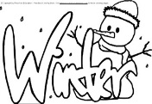
- Disconnect Hoses
- Change Furnace Filter
- Do NOT Apply Salt to Concrete
- Seed Bare Lawn Areas
- Fertilizer & Weed Control
- Clean Gutters & Be Sure Downspouts are Directed Away from Foundation
- Change Furnace Filter
- Use Mower’s Highest Setting
- Test GFI Outlets
- Change Furnace Filter
- Clean Debris Around AC Unit
- Replace Smoke Alarm Batteries
- Seal Concrete Drive & Walks
- Change Furnace Filter
- Check Gutters/Downspouts
- Clear Window Well of Debris

Mike Gardner 513-427-0909, mgardner@cristohomes.com

